

Name : Pouriya

Surname : Nourizadh

Professor’s Name: Dr.Mehdi Islami

Topic: Project DSP

Topic Name: Finding image edges and removing noise

Introduction:

For many years, the model of cellular automata has been proposed to study phenomenological topics, including communication, calculations, construction, growth and development, reproduction of competition in nature. This time, we have brought this powerful machine with the help of image processing to present two powerful algorithms in two important and widely used categories of image processing, namely noise removal and edge detection.

So far, different algorithms have been presented based on classical methods for the two categories of edge detection and noise removal, but each of these methods has its own drawbacks. In this article, we will present two algorithms based on cellular automata for these topics, and at the end, by experimentally comparing these algorithms with the best algorithms presented in the past, we will see that these algorithms perform extremely better than the previous algorithms.

Remarkable results are obtained due to the property of parallel matching of cellular automata. In the following, we will provide some points to improve the algorithm and state the future research

Detecting edges is a fundamental problem in computer vision with many applications, some involving very noisy images. While most edge detection methods are fast, they perform well only on relatively clean images. Indeed, edges in such images can be reliably detected using only local filters. Detecting faint edges under high levels of noise cannot be done locally at the individual pixel level, and requires more sophisticated global processing.

Description:

Simply put, ISO is a measure of how sensitive the camera sensor is to light. The lowest ISO setting on most digital cameras is 50, 100, or 200. In this setting, the camera sensor is the least sensitive to light. At higher settings, such as 3200 or 6400, the sensor is more sensitive to light.

The letters ISO stand for the International Organization for Standardization (the more correct term is the International Organization for Standardization). The International Organization for Standardization sets the standards that camera manufacturers use to calibrate the ISO settings on their cameras.

So lowering your ISO from the 1600s, down to 800 and below will definitely make a big difference in Image Quality (IQ). But it's usually not that simple.

If you don't know about ISO, this will be a big help. But chances are you're using a higher ISO because you're in low light and it's necessary.

On a crop sensor camera (which is probably what you're using), I find that 1600 is actually my favorite max, and preferably much less than that.

On full frame cameras though, 3200 is still acceptable, and with the new Canon and Nikon cameras, you can push it even higher.

If you want to lower your ISO, you'll want to change your shutter speed or aperture accordingly.

Using aperture, I have two parameters, radius and edge detail. They cancel each other out, so if I raise both, I haven't done anything.

The larger your radius, the softer the image. But as you add edge detail, you sharpen it further and add noise detail back into the mix.

In the upper half of the image below, no noise reduction has been added to the image.

The lower half has reduced noise. It looks a little soft. But you have to remember that this product is 100% product, so it magnifies the details.

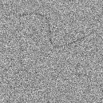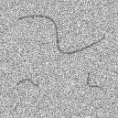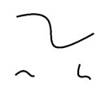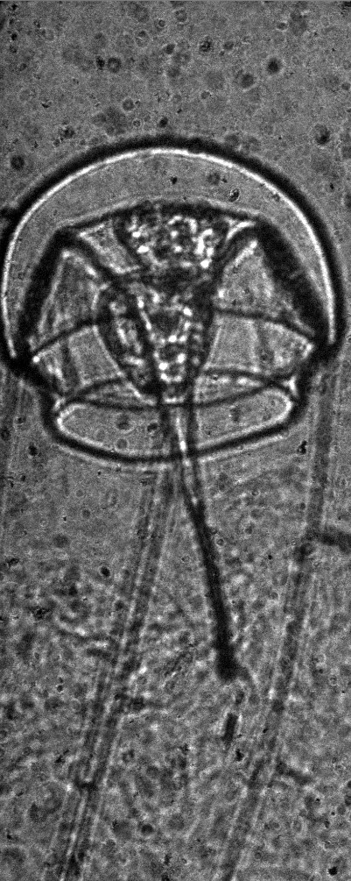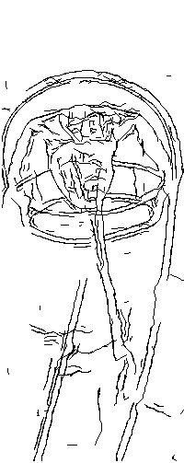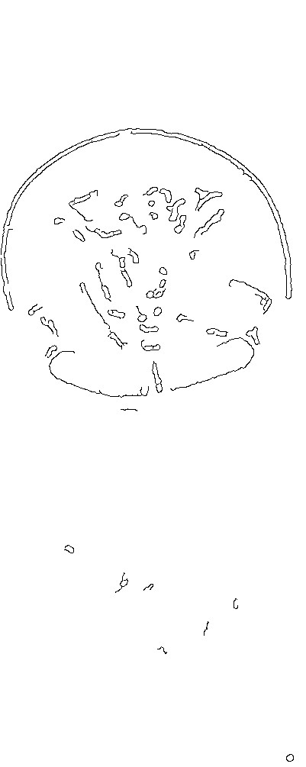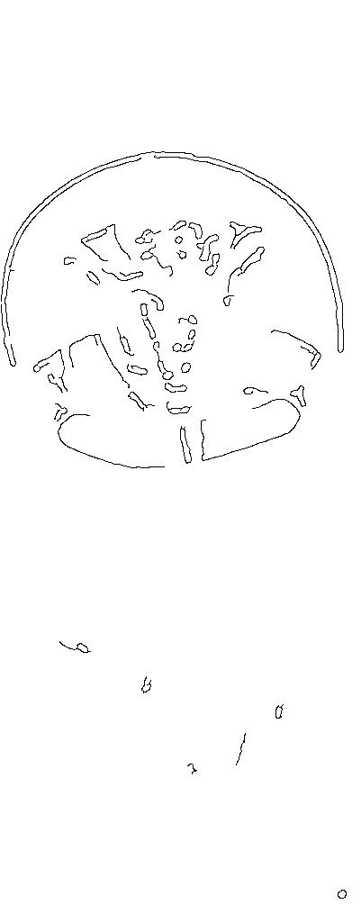

This is consistent with the performance of the human visual system, as can be appreciated from Fig. 1.

Edges with low signal-to-noise-ratio are common in a variety of imaging domains, specifically when images are captured under poor visibility conditions. Examples include biomedical, satellite and high shutter speed imaging. Fig. 2 shows an image of Plankton acquired with an underwater imaging system Exploring ocean ecosystems can benefit from algorithms for segmentation, detection and classification of plankton. Segmenting plankton in such images is challenging due to their low contrast and background noise.

f is the original image and 'f is the recovered image. m and n are the dimensions of the image and 2(f-f) represents the square of the difference between each point of the original image and the recovered image. Therefore, a small value for rms indicates the power of filter recovery, and large values ​​indicate the low quality of the image after applying the filter.

Although rms is a standard for the amount of error of the recovered images from the original images in terms of mathematics, but in some filters such as blurring filters, the rms shows low values ​​if the recovered image is of low quality, so for the comparison of filters, the quality of the image in terms of the sharpness of the edges and Clarity will also be considered in the reviews.

Another parameter to compare filters with each other is the cost of running each filter, for this purpose, all the filters have been scaled in matlab environment and the filter running time has been obtained.

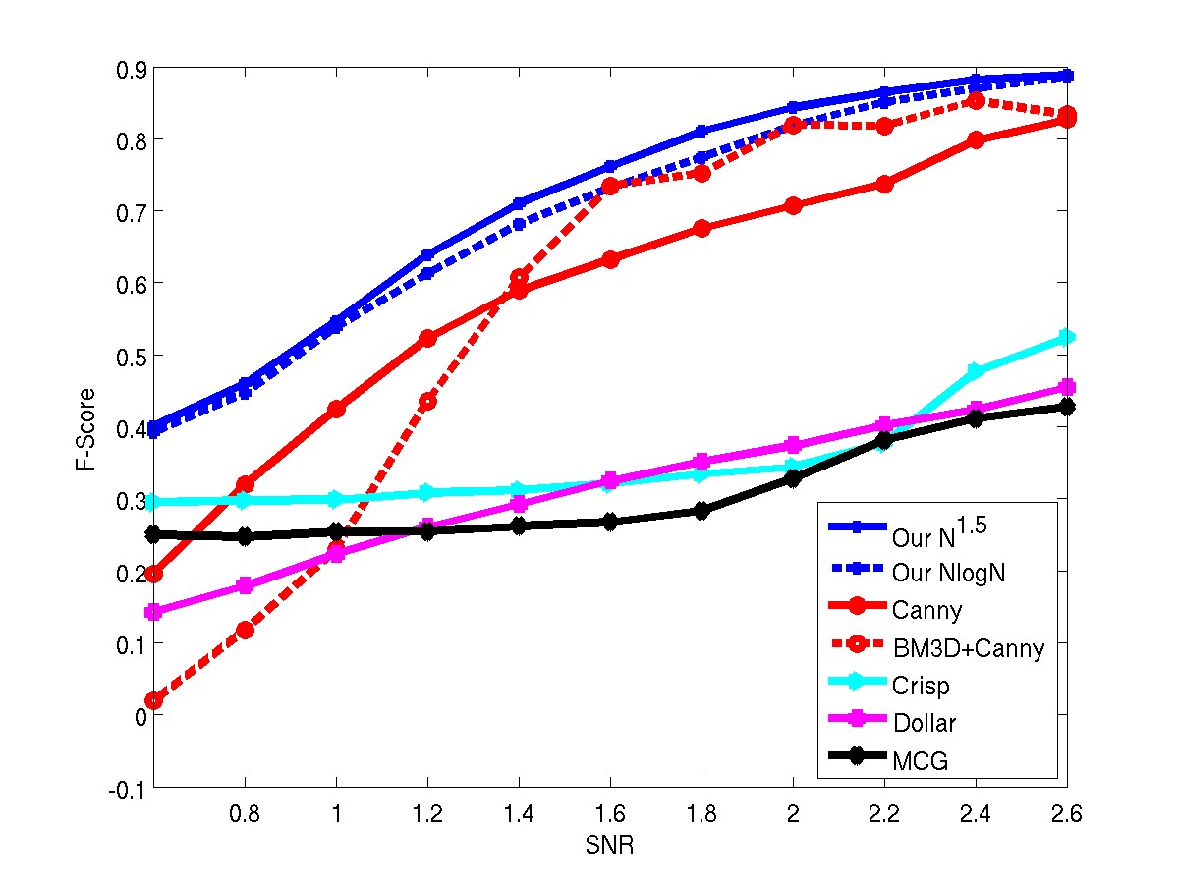

Simulation results and measurements of F with different edge detection algorithms

Types of noise:

Nasvir environmental pollution:

This type of noise occurs over time on images on photo paper or even negatives, and includes dust, liquids, or folding of the photo and wrinkling of the folded part.

Salty pepper noise:

They refer to placing dark points on light areas and bright points on dark areas of the image. This type of noise occurs when converting analog to digital images. Figure b.1 is the noise of salt and pepper with a density of 0.2. The most obvious type of salt and pepper noise can be seen in photocopies taken from images using photocopiers.

Noiz Gossin:

It is noise that is included in the probability density function of normal distribution (known as Gaussian distribution). And usually adding white noise to the image is called (AWGN) 1. Figure c.1 is Gaussian noise with mean 0.2 and variance 01.

Impact noise or Poisson:

Digital sensors that are exposed to light with their fluctuations lead to the emission of photons around and affect the side sensors. This effect is variable according to the level of exposure and its effect on the number of emitted photons, and the resulting noise is called impact noise. Figure d.1 shows the noise of an image stained with Poisson's radiation.

The amount of noise obtained from a pixel is equal to the noise obtained from other points and follows the Poisson distribution. This distribution is almost the same as Gaussian distribution

Reinforcing noise:

This noise is independent of the input signal and is a type of Gaussian noise. It occurs in cameras that increase the intensity of one color, such as blue more than red and green, and is often observed in the dark area of ​​the image.

Granular noise: It is a type of impact noise.

Porous noise:

This type of noise is random and the interference is a sample of images that is the result of the radiation of a large number of the same ultrasonic waves and interfering with each other. Porous noise is obtained in the form of spots on cosmic images or an image that is obtained from the reflection of sunlight on a nail, or from laser radiation, etc. [3, 6, 14]. In figure e.1, the spots resulting from porous noise with a variance of 0.2 can be easily seen, and in figure f.1, the green spots captured by the digital camera from the green laser bar can be seen.

Noise removal filters

Noisy images are recovered in two domains: location and frequency, and due to the high cost of frequency domain processing, noise removal filters in the location domain are more important [5, 10].

Local filtering 4 or neighborhood processing includes the following steps:

Definition of the neighborhood to the center of the point (x,y)

Applying an operator 5 to the pixels enclosed in the neighborhood of the point (x,y)

Considering the result of the operator as the answer at the point (x,y)

Repeat processing for all image points

If the calculations performed for the neighboring points are linear, this operation is called linear spatial filtering or spatial convolution. Otherwise, it is called non-linear spatial filtering.

Removing the noise by using the mask and replacing the pixel value with the average or median or the weighted average of the points inside the mask, etc., although it removes the noise of the image, but in most cases it leads to smoothing the edges and blurring the image.

Median filters:

Average filters are obtained based on the weighted value of the points placed in the mask, which are 4 common average examples in mathematics below:

The most famous average filter is the arithmetic mean, which is a type of linear filter. This filter has been used more than other average filters, its implementation is easier and cheaper. Average filters:

Average filters are obtained based on the weighted value of the points placed in the mask, which are 4 common average examples in mathematics below [1]:

The most famous average filter is the arithmetic mean, which is a type of linear filter. This filter has been used more than other average filters, its implementation is easier and cheaper.

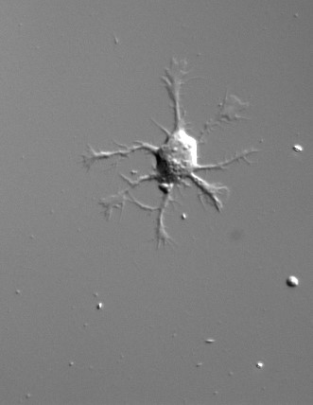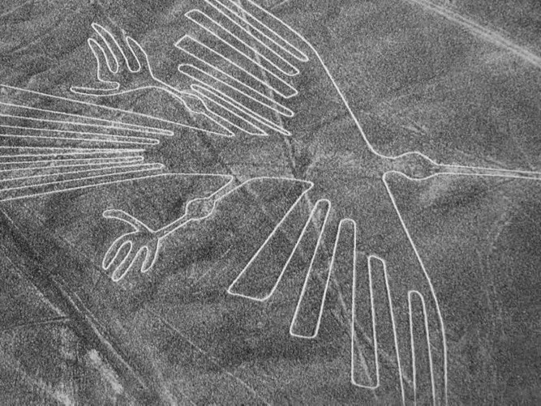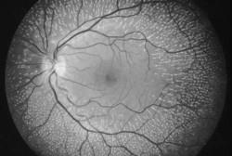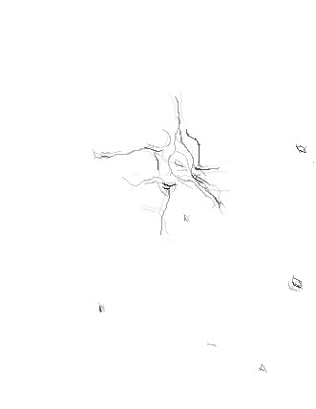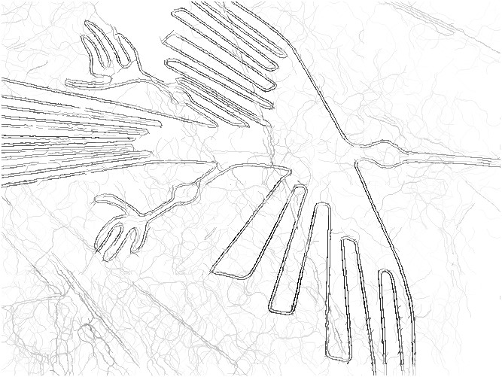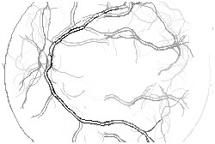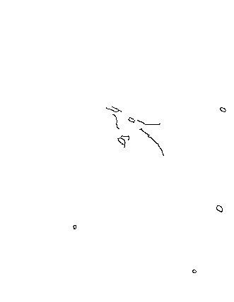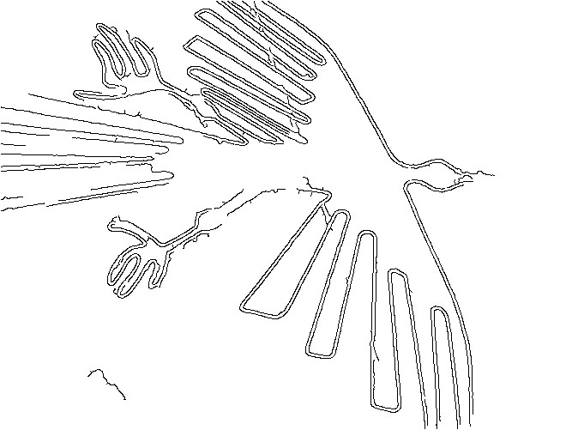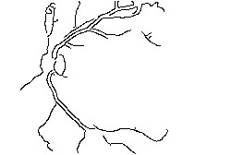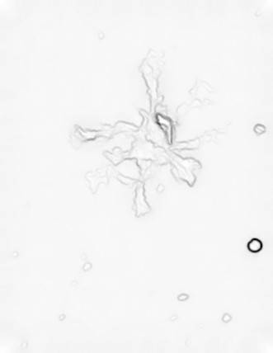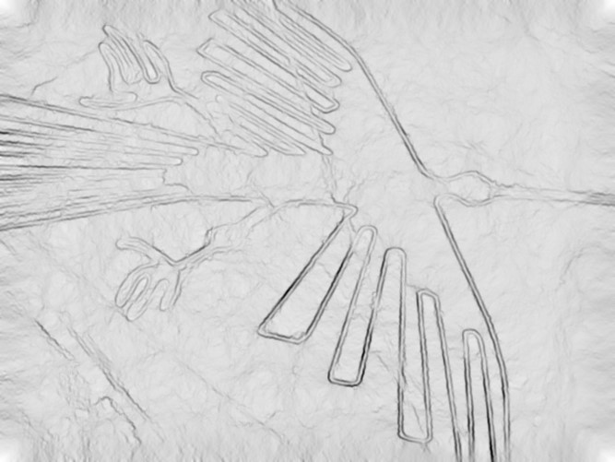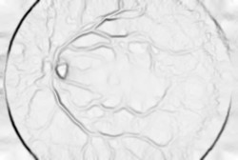

Real images: Each column shows the original image and a comparison of our results with those obtained by other algorithms. From top to bottom: The input image; our *O* (*N*1*.*5) algorithm; Canny and Crisp

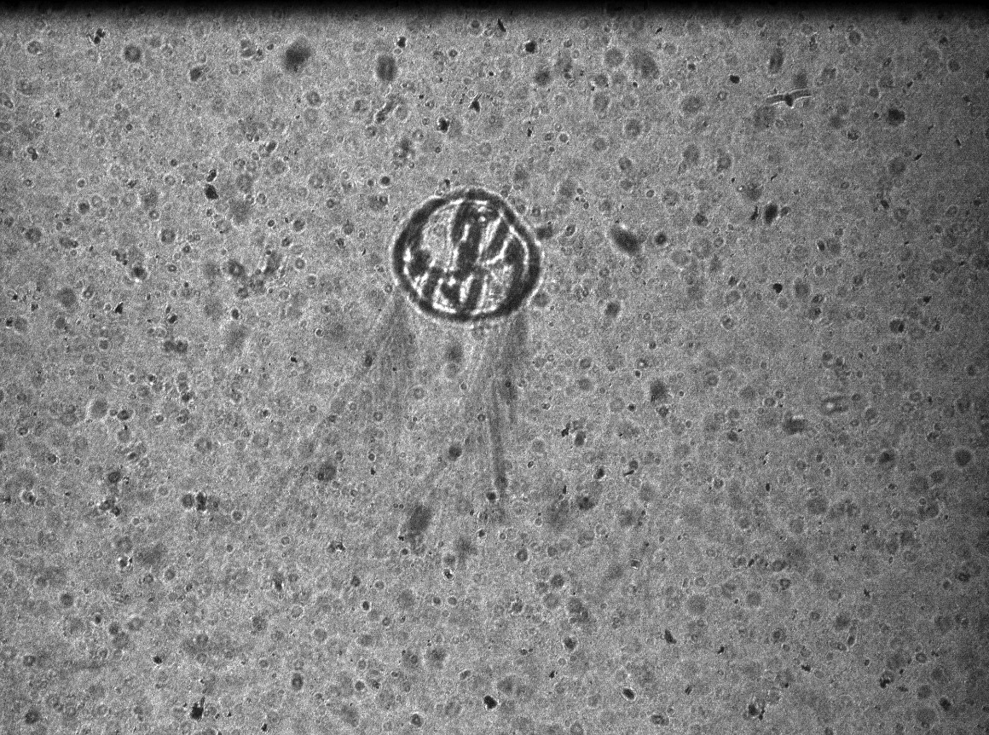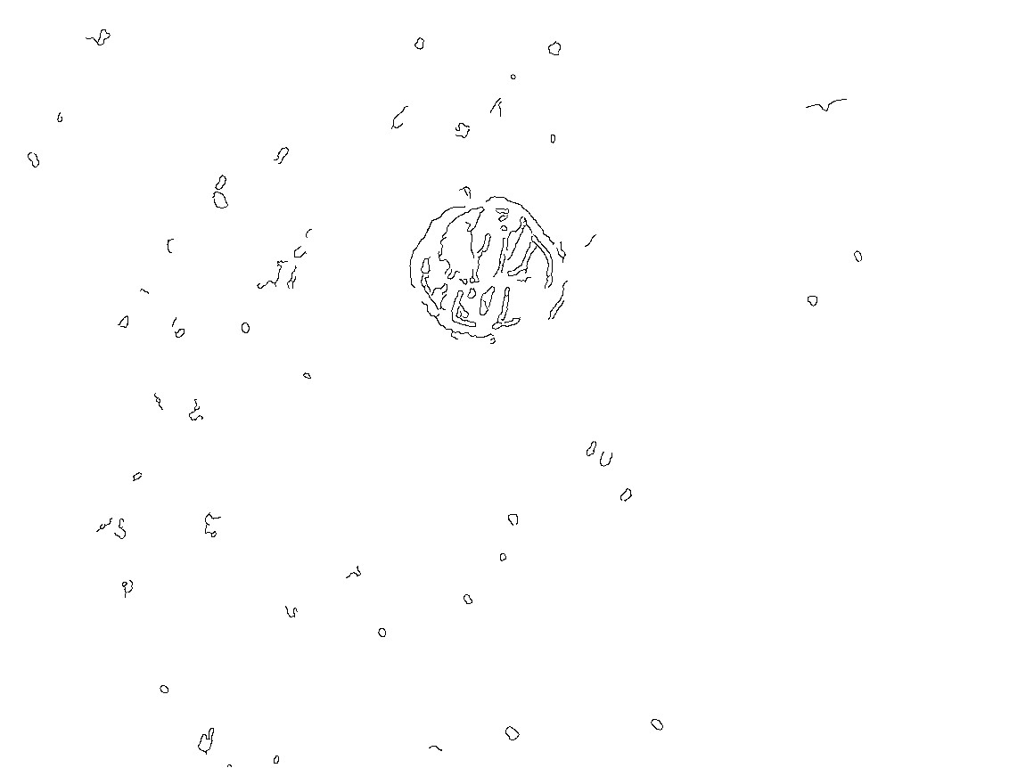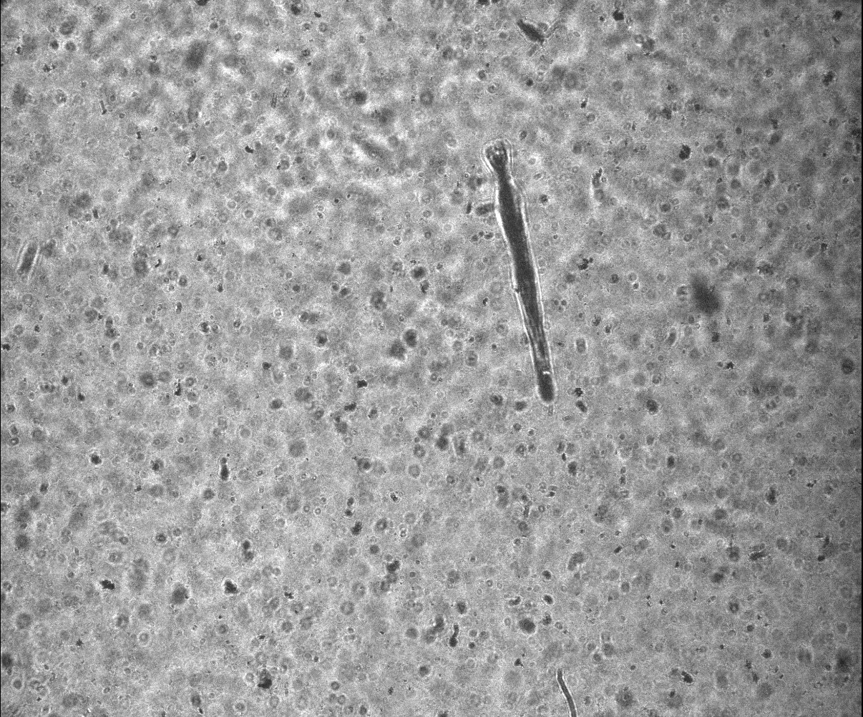

Underwater microscope example: Each row shows a Plankton image along with corresponding results. From left to right: the input image; our result and Canny result.

The results of the root mean square error for all the above 4 averages and contaminated images b,c,d,e from Figure 1 are given in Table 1. Figure 2 also shows the results of the filters on the image contaminated with Gaussian noise. As can be seen, the error of harmonic and geometric filters are close to each other and the error of arithmetic and second order filters are also close to each other. And there is a relationship between the rms of these averages

The recovery of the original image is higher in the arithmetic mean. But the edges and details of the image in rank 2 have been preserved relatively more.

Although the harmonic and geometric filters have less rms than the noise-contaminated filter, they have not improved the quality of the image and have created large spots of porous noise on the image. So, the quality of the picture has dropped a lot due to the salt and pepper noise. The processing cost of arithmetic filter is lower than other filters and it has higher quality.

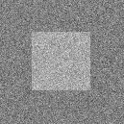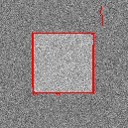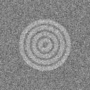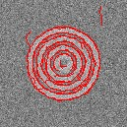

In these filters, the samples of the mask members are first sorted in ascending order, and then, based on the type of filter, a sample is selected and returned as the filter answer. Therefore, the answer of the filter is independent of the weight and values ​​of all mask samples, all these filters are included in the non-linear group. 4 filters used in image processing and noise removal are listed below

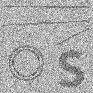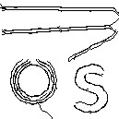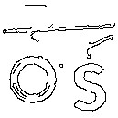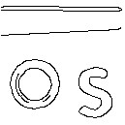

Result of applying various edge detection algorithms to the noisy simulation image. From left to right: Input noisy image at SNR 2, our *O* (*N*1*.*5) algorithm, Canny best result and Canny after BM3D denoising.

Conclusion :

It destroys the presence of image noise and always aims to remove it from the images

we have . In this article, while examining some examples of standard processing filters

Image and fuzzy filters are presented as a new technique for noise reduction

The image was also provided. We observed that the average filter in addition to noise removal

It causes crystal formation and darkening of the image. Performance filter

It is better than the average filter, but still for Gaussian noises

Noisy images are not suitable. Hence the phase filters that fit the noise

The ones in the image are filtered in different ways

are In the provided filter, take action according to the noise level of each pixel

Filtering operation and noise reduction of each pixel

As

We observed that the provided filter has a better performance in reducing image noise

especially Gaussian noise

We presented efficient algorithms for detecting faint curved edges in noisy images that achieve state-of-the-art results in low SNRs. We introduced a novel approach for detecting curved edges in an image in *O*(*N* log*N*) operations. Importantly, the algorithm is adaptive to various parameters such as edge length, shape, and SNR. Thus it may be applicable in a variety of imaging domains. Our approach can be extended to efficiently detect edges in 3D images, which are frequently used in medical imaging. In addition, it

References :

1. D. Marr and E. Hildreth. Theory of Edge Detection. *Proceedings of the Royal Society of London. Series B, Biological Sciences*, 207(1167):187–217, 1980.
2. D. R. Martin, C. C. Fowlkes, and J. Malik. Learning to detect natural image boundaries using local brightness, color, and texture cues. *IEEE Trans. Pattern Anal. Mach. Intell.*, 26(5):530–549, May 2004.
3. P. Perona and J. Malik. Scale-space and edge detection using anisotropic diffusion. *IEEE Transactions on Pattern Analysis and Machine Intelligence*, 12:629–639, 1990.
4. I. Sobel. Camera models and machine perception. In *PhD thesis, Electrical Engineering Department, Stanford University.*, 1970.
5. C. Tomasi and R. Manduchi. Bilateral filtering for gray and color images. In *Computer Vision, 1998. Sixth International Conference on*, pages 839–846, 1998.

P. S. P. Wang and J. Yang. A review of wavelet-based edge detection methods. *IJPRAI*, 26